Волков Григорий P3132 Вариант 30

Исходная таблица соединений R:

|  |  |  |  |  |  |  |  |  |  |  |  |  |
| --- | --- | --- | --- | --- | --- | --- | --- | --- | --- | --- | --- | --- |
| V/V | **e1** | **e2** | **e3** | **e4** | **e5** | **e6** | **e7** | **e8** | **e9** | **e10** | **e11** | **e12** |
| **e1** | 0 |  |  |  | 1 | 1 |  | 4 | 4 |  |  | 5 |
| **e2** |  | 0 |  |  |  | 3 |  | 5 | 1 |  | 4 | 5 |
| **e3** |  |  | 0 |  |  |  |  | 5 |  | 2 | 3 |  |
| **e4** |  |  |  | 0 | 5 | 2 |  |  |  | 5 | 4 | 2 |
| **e5** | 1 |  |  | 5 | 0 |  |  | 1 |  |  |  |  |
| **e6** | 1 | 3 |  | 2 |  | 0 | 1 |  | 2 | 1 | 4 |  |
| **e7** |  |  |  |  |  | 1 | 0 | 1 | 2 | 3 | 1 | 3 |
| **e8** | 4 | 5 | 5 |  | 1 |  | 1 | 0 | 1 | 4 |  | 4 |
| **e9** | 4 | 1 |  |  |  | 2 | 2 | 1 | 0 |  | 4 | 4 |
| **e10** |  |  | 2 | 5 |  | 1 | 3 | 4 |  | 0 |  |  |
| **e11** |  | 4 | 3 | 4 |  | 4 | 1 |  | 4 |  | 0 | 5 |
| **e12** | 5 | 5 |  | 2 |  |  | 3 | 4 | 4 |  | 5 | 0 |

|  |  |  |  |  |  |  |  |  |  |  |  |  |  |
| --- | --- | --- | --- | --- | --- | --- | --- | --- | --- | --- | --- | --- | --- |
| V/V | **e1** | **e2** | **e3** | **e4** | **e5** | **e6** | **e7** | **e8** | **e9** | **e10** | **e11** | **e12** | **ri** |
| **e1** | 0 |  |  |  | 1 | 1 |  | 1 | 1 |  |  | 1 | **5** |
| **e2** |  | 0 |  |  |  | 1 |  | 1 | 1 |  | 1 | 1 | **5** |
| **e3** |  |  | 0 |  |  |  |  | 1 |  | 1 | 1 |  | **3** |
| **e4** |  |  |  | 0 | 1 | 1 |  |  |  | 1 | 1 | 1 | **5** |
| **e5** | 1 |  |  | 1 | 0 |  |  | 1 |  |  |  |  | **3** |
| **e6** | 1 | 1 |  | 1 |  | 0 | 1 |  | 1 | 1 | 1 |  | **7** |
| **e7** |  |  |  |  |  | 1 | 0 | 1 | 1 | 1 | 1 | 1 | **6** |
| **e8** | 1 | 1 | 1 |  | 1 |  | 1 | 0 | 1 | 1 |  | 1 | **8** |
| **e9** | 1 | 1 |  |  |  | 1 | 1 | 1 | 0 |  | 1 | 1 | **7** |
| **e10** |  |  | 1 | 1 |  | 1 | 1 | 1 |  | 0 |  |  | **5** |
| **e11** |  | 1 | 1 | 1 |  | 1 | 1 |  | 1 |  | 0 | 1 | **7** |
| **e12** | 1 | 1 |  | 1 |  |  | 1 | 1 | 1 |  | 1 | 0 | **7** |

Перенумерованный граф

|  |  |  |  |  |  |  |  |  |  |  |  |  |  |
| --- | --- | --- | --- | --- | --- | --- | --- | --- | --- | --- | --- | --- | --- |
| V/V | **y1** | **y2** | **y3** | **y4** | **y5** | **y6** | **y7** | **y8** | **y9** | **y10** | **y11** | **y12** | **ri** |
| **y1** | 0 | 1 | 0 | 1 | 0 | 1 | 0 | 0 | 0 | 1 | 0 | 1 | **5** |
| **y2** | 1 | 0 | 1 | 0 | 0 | 1 | 0 | 0 | 0 | 0 | 0 | 0 | **3** |
| **y3** | 0 | 1 | 0 | 1 | 0 | 0 | 0 | 1 | 0 | 0 | 1 | 1 | **5** |
| **y4** | 1 | 0 | 1 | 0 | 1 | 0 | 0 | 1 | 1 | 1 | 1 | 0 | **7** |
| **y5** | 0 | 0 | 0 | 1 | 0 | 1 | 0 | 0 | 0 | 1 | 1 | 1 | **5** |
| **y6** | 1 | 1 | 0 | 0 | 1 | 0 | 1 | 1 | 1 | 1 | 0 | 1 | **8** |
| **y7** | 0 | 0 | 0 | 0 | 0 | 1 | 0 | 1 | 0 | 0 | 1 | 0 | **3** |
| **y8** | 0 | 0 | 1 | 1 | 0 | 1 | 1 | 0 | 1 | 0 | 0 | 0 | **5** |
| **y9** | 0 | 0 | 0 | 1 | 0 | 1 | 0 | 1 | 0 | 1 | 1 | 1 | **6** |
| **y10** | 1 | 0 | 0 | 1 | 1 | 1 | 0 | 0 | 1 | 0 | 1 | 1 | **7** |
| **y11** | 0 | 0 | 1 | 1 | 1 | 0 | 1 | 0 | 1 | 1 | 0 | 1 | **7** |
| **y12** | 1 | 0 | 1 | 0 | 1 | 1 | 0 | 0 | 1 | 1 | 1 | 0 | **7** |

Для графа G1

$$\sum{ρ(e)=68}$$

Список P(E) = {8, 7, 7, 7, 7, 6, 5, 5, 5, 5, 3, 3}

Для графа G2

$$\sum{ρ(y)=68}$$

Список P(E) = {8, 7, 7, 7, 7, 6, 5, 5, 5, 5, 3, 3}

|  |  |  |  |  |  |
| --- | --- | --- | --- | --- | --- |
|  | $$ρ(e)= ρ(y) = 8$$ | $$ρ(e)= ρ(y) = 7$$ | $$ρ(e)= ρ(y) = 6$$ | $$ρ(e)= ρ(y) = 5$$ | $$ρ(e)= ρ(y) = 3$$ |
| e | e8 | e6, e9, e11, e12 | e7 | e1, e2, e4, e10 | e3, e5 |
| y | y6 | y4, y10, y11, y12 | y9 | y1, y3, y5, y8 | y2, y7 |

Из таблицы видны следующие соответствия графа:

|  |  |
| --- | --- |
| e | y |
| e8 | y6 |
| e7 | y9 |

Попробуем связать вершины для класса 7

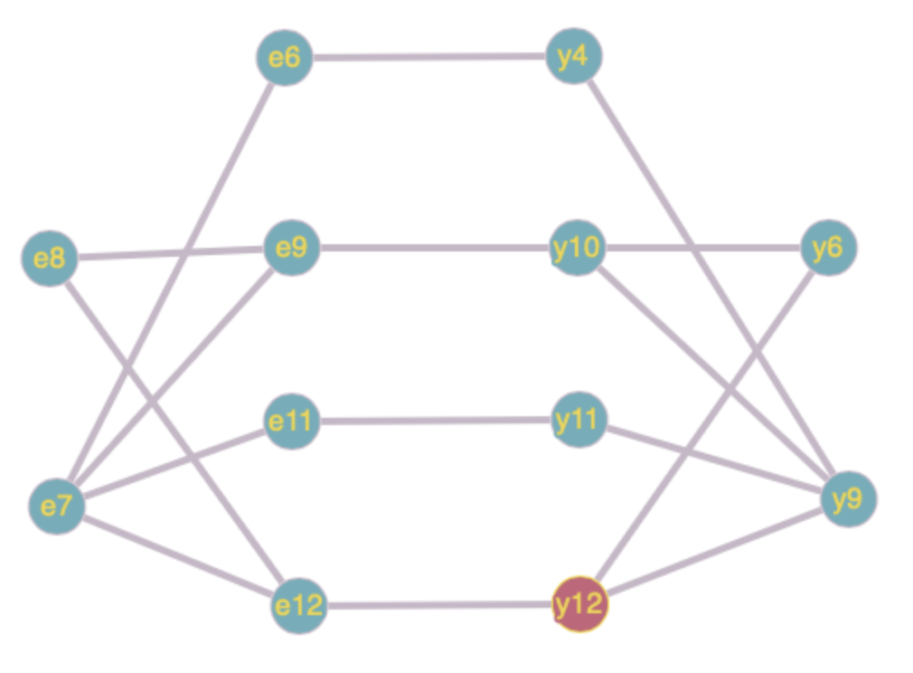

Из анализа видно соответствие: e6 и y4, e9 и y10, e11 и y11, e12 и y12

Попробуем связать вершины для класса 5

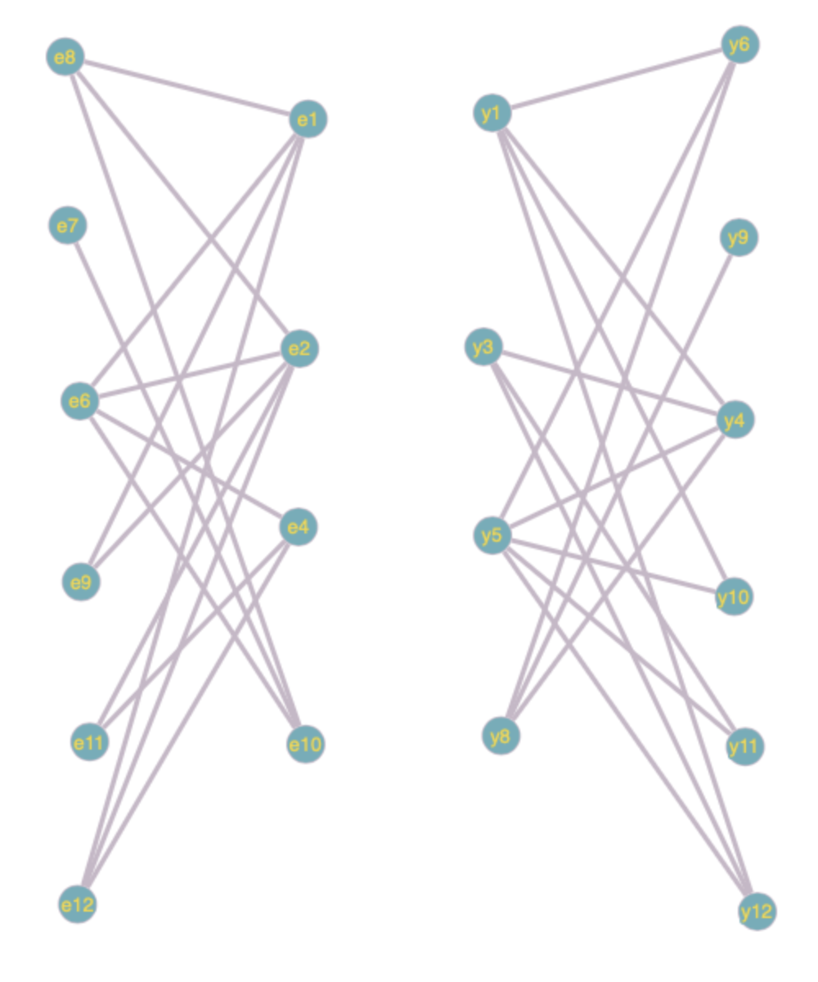

Из анализа видно соответствие: e1 и y1, e2 и y5, e4 и y3, e10 и y8

Попробуем связать вершины для класса 3

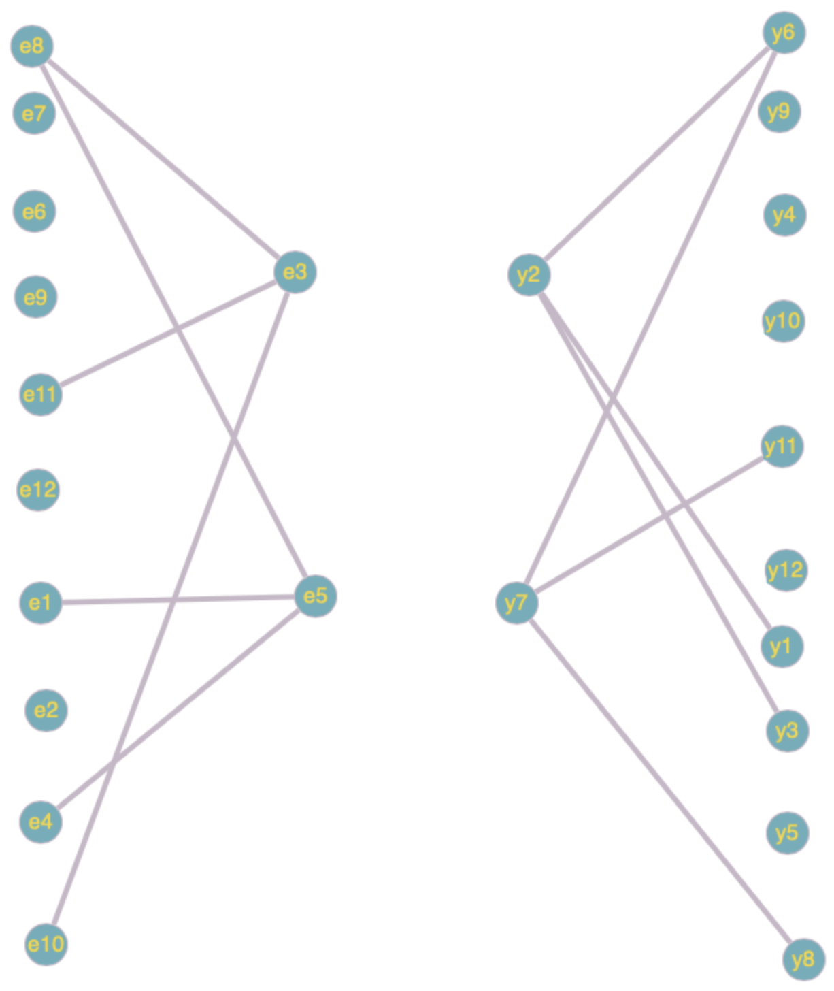

Из анализа видно соответствие e3 и y7, e5 и y2

Итоговая таблица

|  |  |
| --- | --- |
| e | y |
| e8 | y6 |
| e7 | y9 |
| e6 | y4 |
| e9 | y10 |
| e11 | y11 |
| e12 | y12 |
| e1 | y1 |
| e2 | y5 |
| e4 | y3 |
| e10 | y8 |
| e3 | y7 |
| e5 | y2 |

По итоговой таблице видно, что каждой вершине графа G1 соответствует одна вершина графа G2. Тогда можно сказать, что графы изоморфны